SPH4U Relative Motion Date :________________

Minds On :

You are on a train travelling at 50.0 km/h [Forward]. If you walk forward on the train at 5.0 km/h relative to the train floor, what is your velocity relative to the ground?

If you now walk backward on the train at 5.0 km/h relative to the train floor, what is your velocity relative to the ground?

Introduction:
All motion is relative!

The description of a motion depends upon the _________________________________ or point of view from which we describe motion.

Our most common frame of reference from which we describe motion is the ___________ which we assume to be ______________.

In other cases, our frame of reference may be another object which is also in motion!

Examples of how the Frame of Reference impacts our perception of motion:

Case 1: You are on a skateboard rolling at a constant speed forward and throw a ball straight up in the air. Describe the ball’s motion from :

- Your perspective b) the perspective of a stationary
observer on the ground

Case 2: A package is dropped from a plane moving at a constant velocity. Ignoring air resistance, describe the trajectory of the package from

- The perspective of a person on the plane b) the perspective of a stationary
observer on the ground

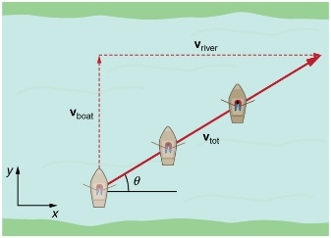
SPH4U Relative Velocity- Sample Questions Date:_______________

Using the Chain Rule in One Dimension!

- a) A person is walking East at 5.0 km/h relative to train which is travelling at 42.0 km/h [ East]. What is the person’s velocity relative to the ground?

b) What is the person’s velocity relative to the ground if the person is walking at 5.0 km/h West
relative to the train?

2-D River Crossing Question:
- A swimmer who can swim at 4.0 m/s in still water, heads north as they swim across a river with a current of 2.5 m/s East.

- Approximately where will the swimmer land relative to their starting position?

- What is their resultant velocity relative to shore?

- In what direction would the swimmer have to head in order to swim directly NORTH across the river?

Airplane Navigation Question
The displacement from Toronto to Houston, Texas is 1.55 x 10 ³ km [ S 35.0° W]. There is a wind of 115 km/h from the west. If a pilot wants to fly directly between the two cities in a time of 3.00 hours, what velocity relative to air must she maintain?

